**Random Number Generation in JavaScript Building a Love Calculator**

**Random Pseudo Number Generation:**

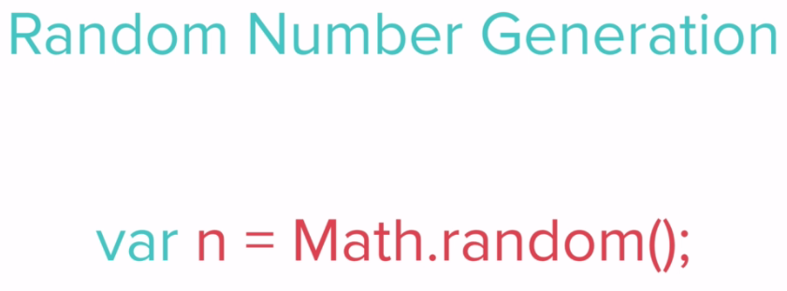

JS random number is between 0 to 0.9999999999999999 (16 decimal places)

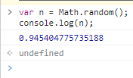

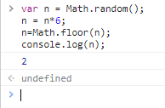

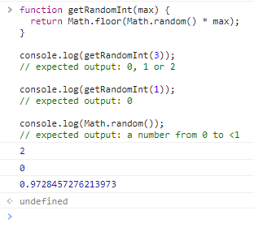

**Math.random()**

The **Math.random()** function returns a floating-point, pseudo-random number in the range 0 to less than 1 (inclusive of 0, but not 1) with approximately uniform distribution over that range — which you can then scale to your desired range. The implementation selects the initial seed to the random number generation algorithm; it cannot be chosen or reset by the user.

<https://developer.mozilla.org/en-US/docs/Web/JavaScript/Reference/Global_Objects/Math/random>

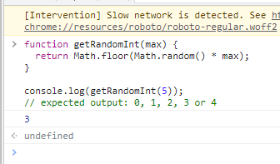

**Note:** Expected output is from **0** to **max-1**.

**Pseudo Random Number**

var n=Math.random();

n=n*6;

n=Math.floor(n)+1;

console.log(n);

The difference between true random number generators(TRNGs) and pseudo-random number generators(PRNGs) is that **TRNGs use an unpredictable physical means to generate numbers (like atmospheric noise), and PRNGs use mathematical algorithms (completely computer-generated)**.

<https://youtu.be/GtOt7EBNEwQ> //see this video

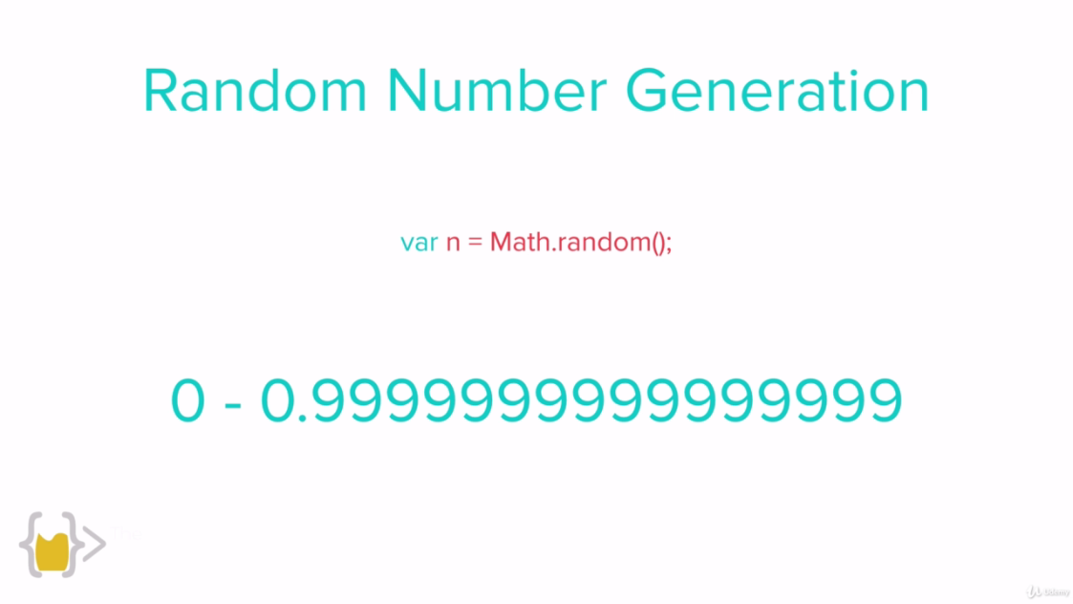

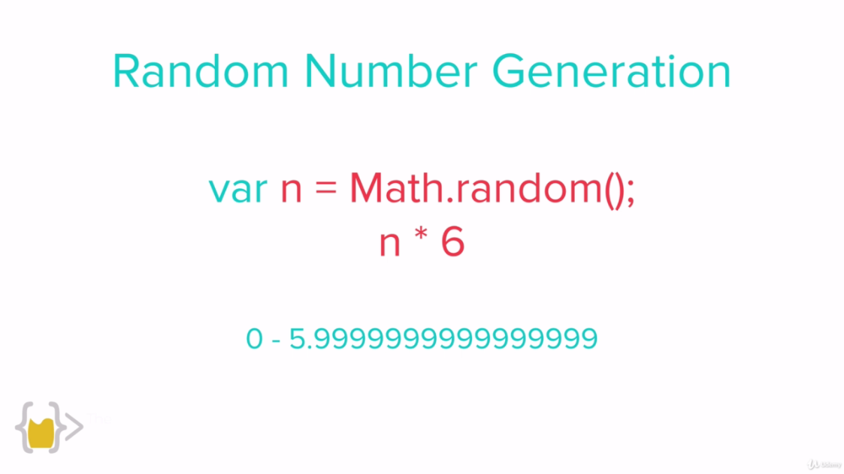

For dice number generator because dice has 6 sides

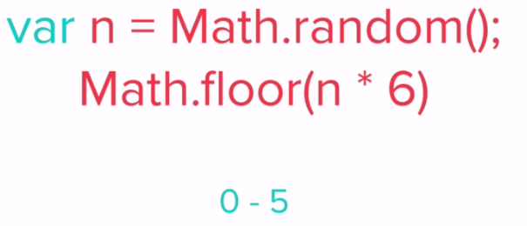

How to generate perfect random number fir dice.

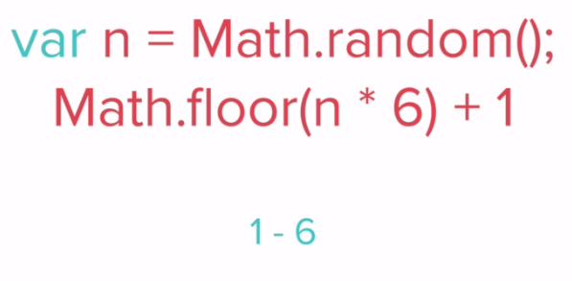

And we know that dice number range is from 1-6.

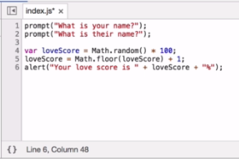

**Love Calculator:**

//prompt("What is your name?);

//prompt("What is their name?);

var loveScore = Math.random()*100;

loverScore = Math.floor(loveScore);

loveScore = Math.floor(loveScore)+1;

alert("Your love score is: "+loveScore+"%");